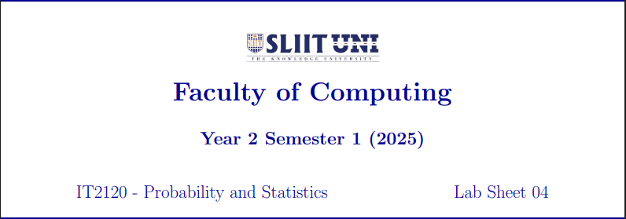

Weliweriya W L P T

IT24100072

3.This is a Right-skewed distribution.

